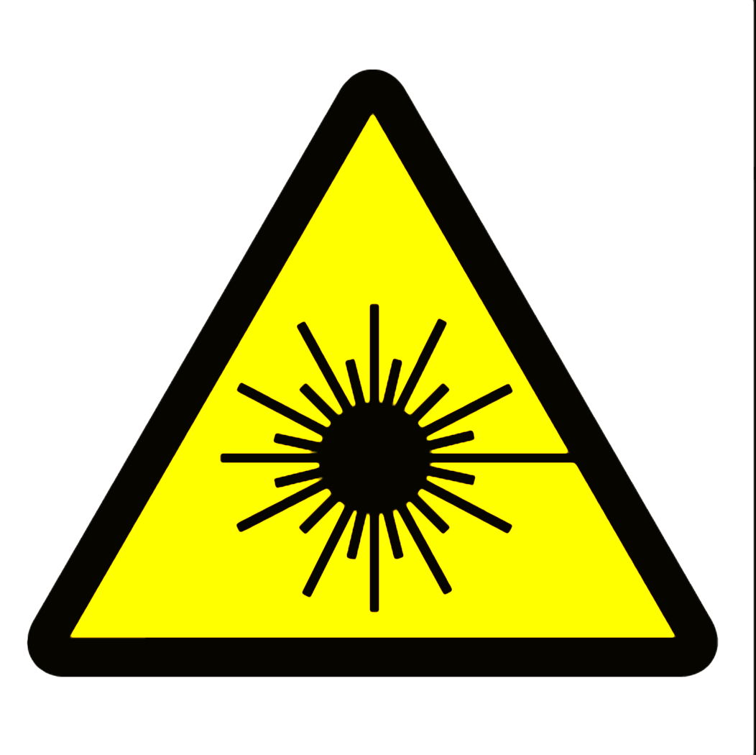

WARNING
Class 4 Laser Controlled Area
Avoid eye or skin exposure to direct or scattered radiation
Do not enter when light is illuminated
Laser eye protection required: OD > 5@532 nm
Diode-pumped solid state (DPSS) laser, 532 nm
10 watts
Laser Safety Officer _____________________ Phone ______________

This label is intended for areas using lasers of Class 3B, or Class 4 less than 1 kW (1000 watts). Change warning text, laser type, wavelength and power to suit your specific situation. Consult ANSI Z136.1 or a qualified laser safety officer to ensure accuracy.

