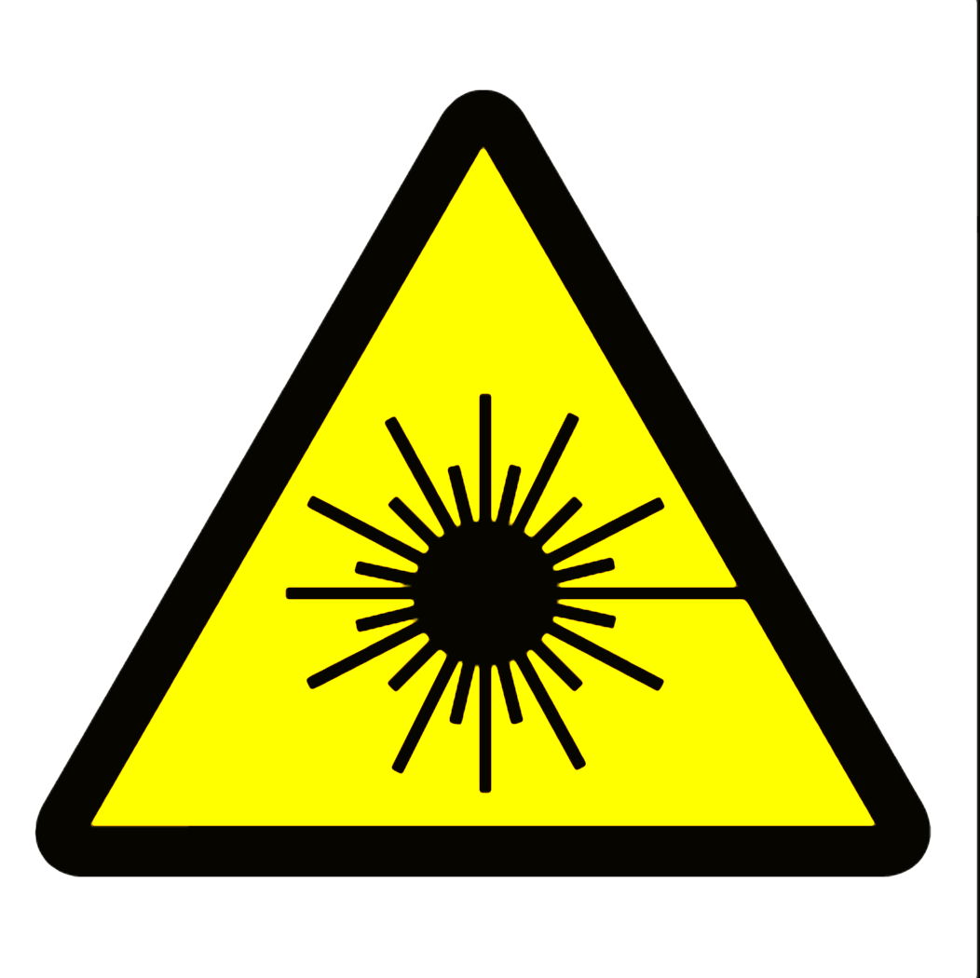

DANGER
Class 4 Laser Controlled Area
Avoid eye or skin exposure to direct or scattered radiation
Do not enter when light is illuminated
Laser eye protection required: OD>7@1060 nm
CO2 laser, 1060 nm
5 kW
Laser Safety Officer _____________________ Phone ______________

This label is intended for areas using lasers of 1 kW (1000 watts) power or greater. Change warning text, laser type, wavelength and power to suit your specific situation. Consult ANSI Z136.1 or a qualified laser safety officer to ensure accuracy.

