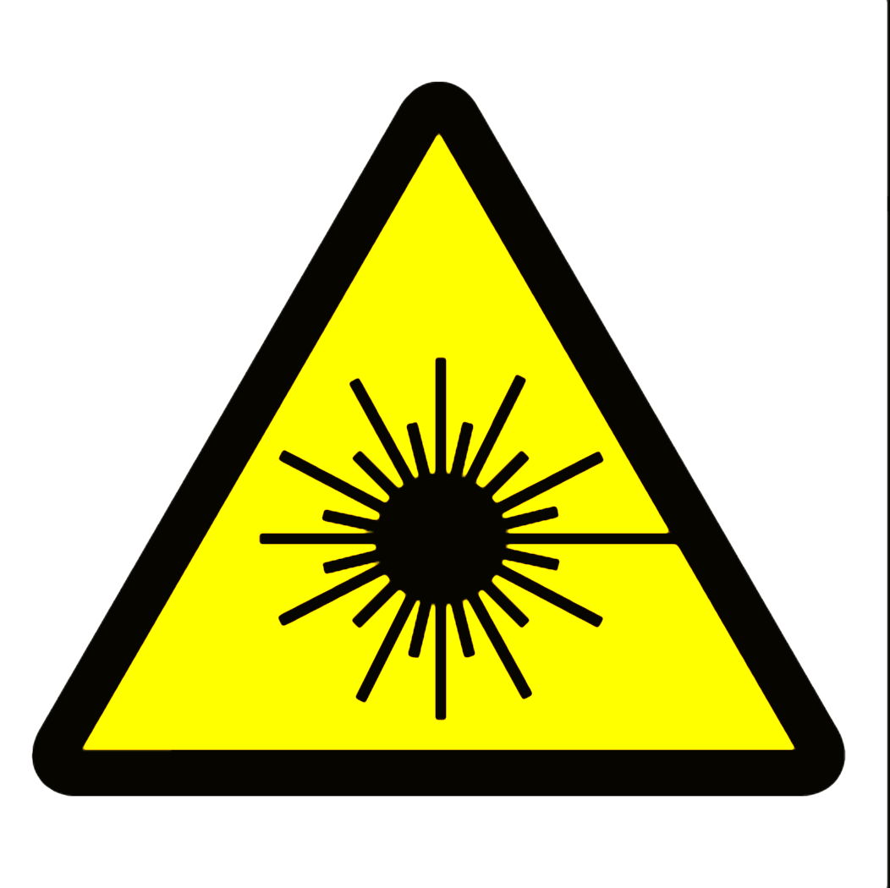

CAUTION
Class 3R Laser in Use
Avoid eye exposure to direct radiation
Do not enter when light is illuminated

Diode laser, 535 nm
< 5 milliwatts

Laser Safety Officer _____________________ Phone ______________

This label is intended for areas using Class 2 or 3R lasers -- to alert persons that laser light is in use. Change warning text, laser type, wavelength and power to suit your specific situation. Consult ANSI Z136.1 or a qualified laser safety officer to ensure accuracy.

